Step 1: Intially cloned the build from the Devops-build repo

Repo link: <https://github.com/sriram-R-krishnan/devops-build.git>

My Repository link: <https://github.com/vineeth2113/Capstone-project.git>

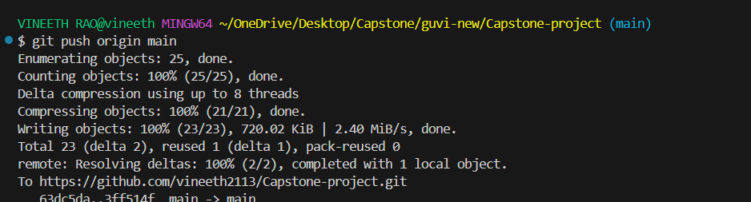

**Step - 2 Dockerizing the application**

* Creating the docker file.
* Creating the docker compose file.

**Step – 3 creating the build.sh and deploy.sh**

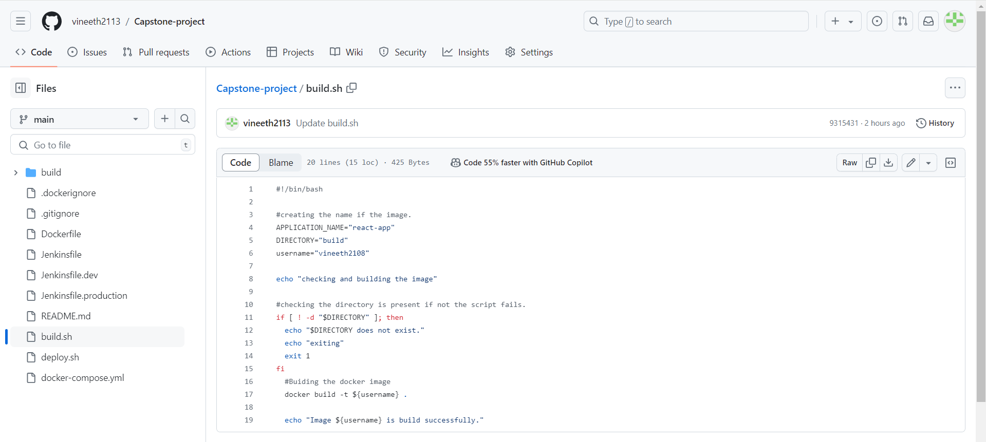

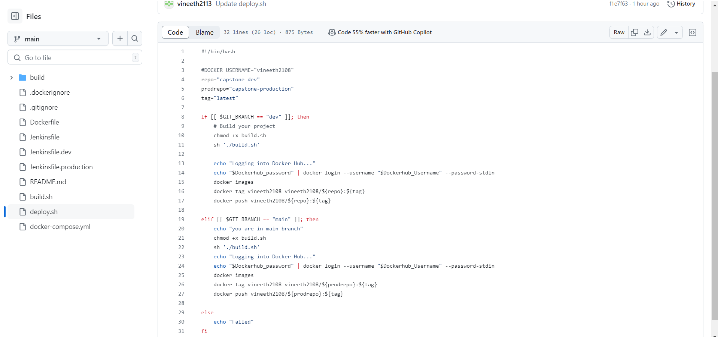

Jenkins:

1. Jenkins configured and installed the respective plugins.
2. Created the multibranch pipeline.

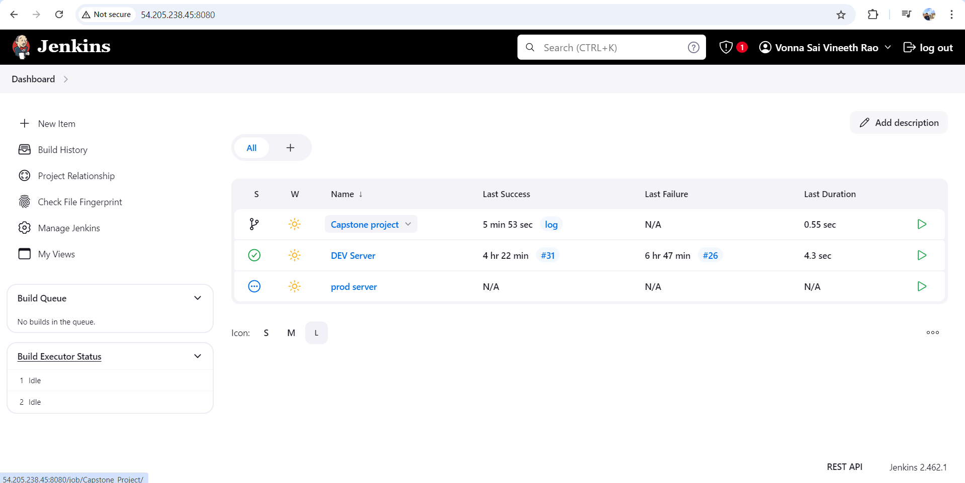

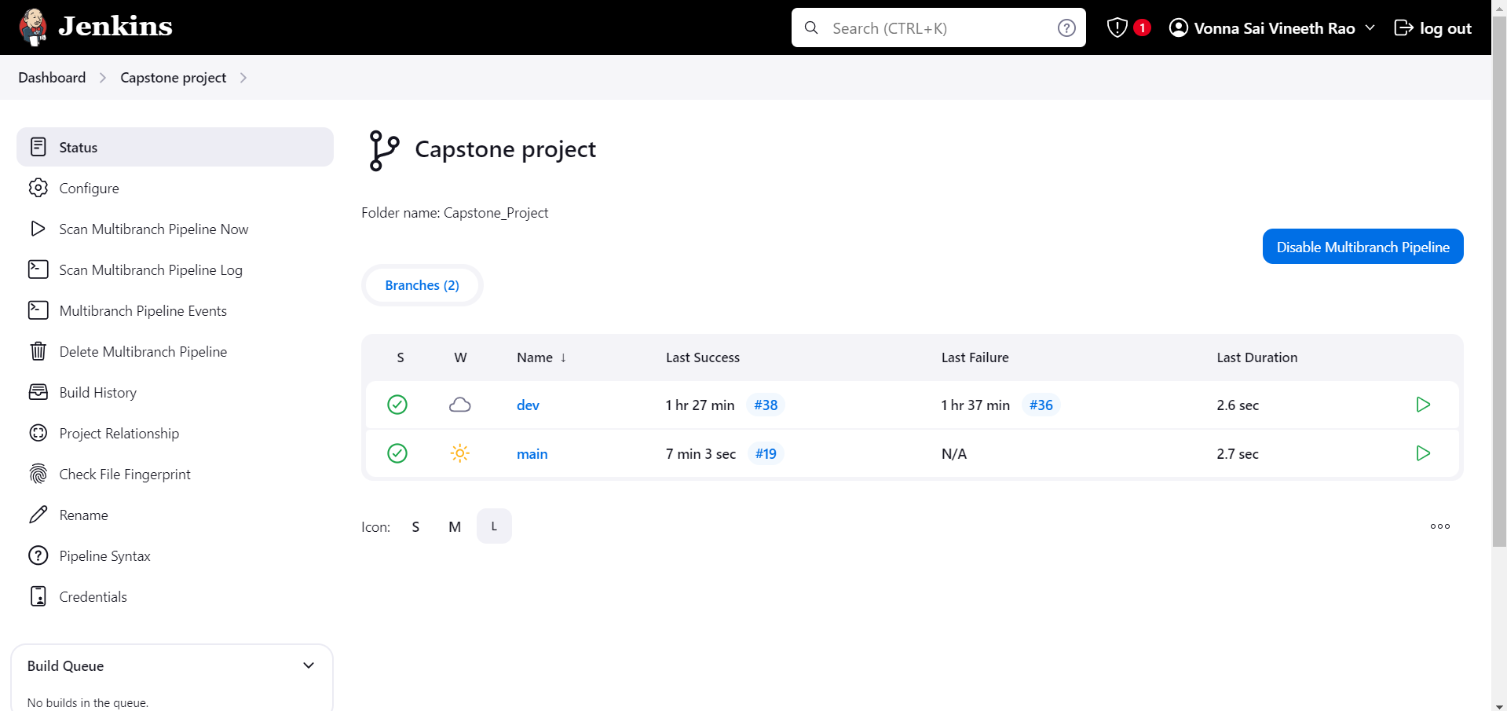

Webhook settings:

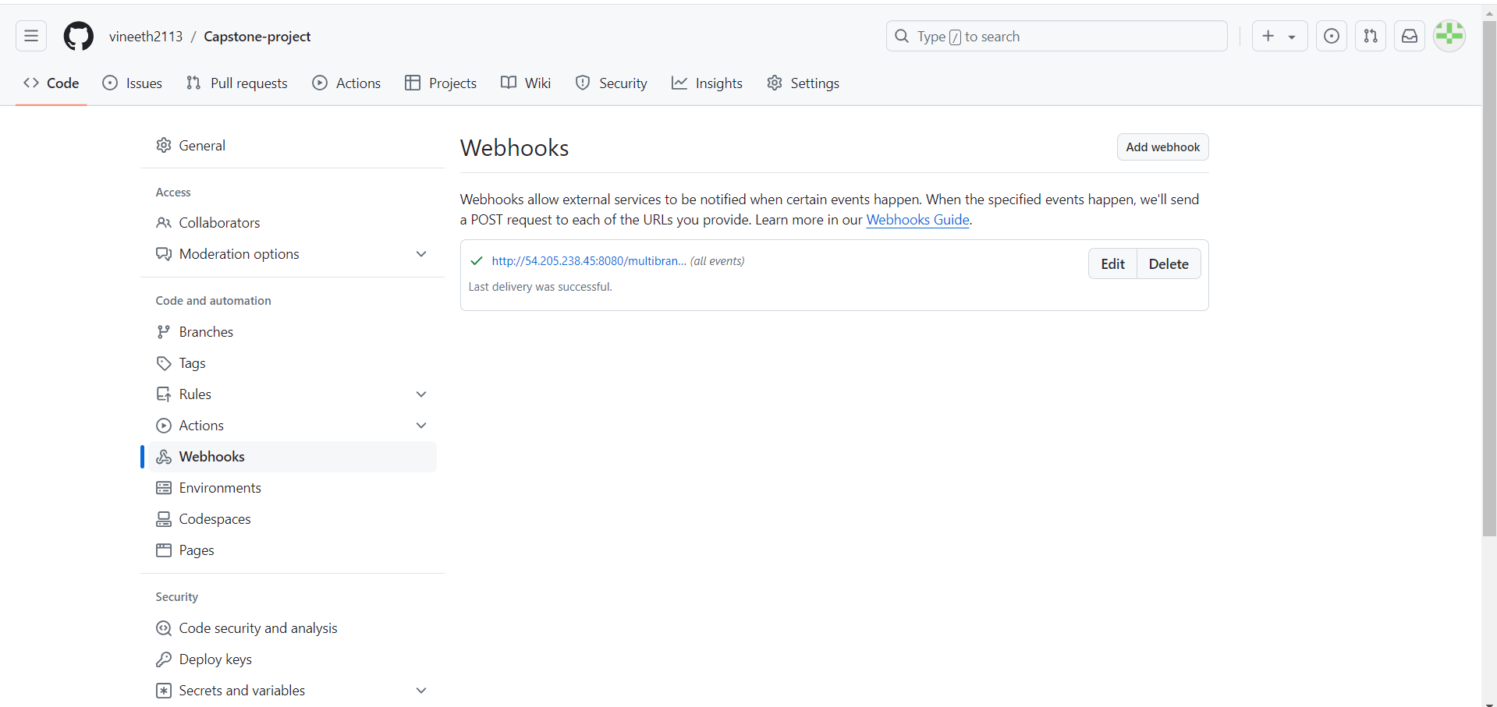

Pipeline configure:

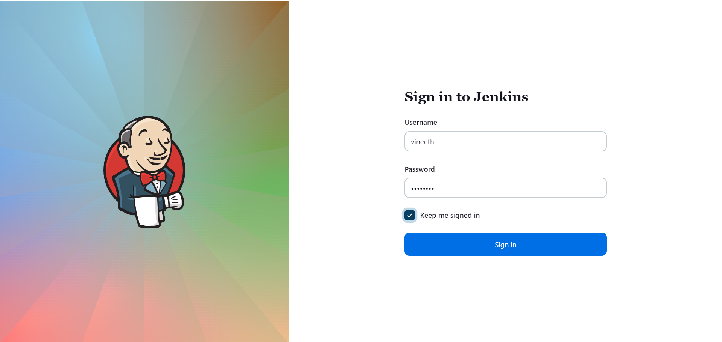

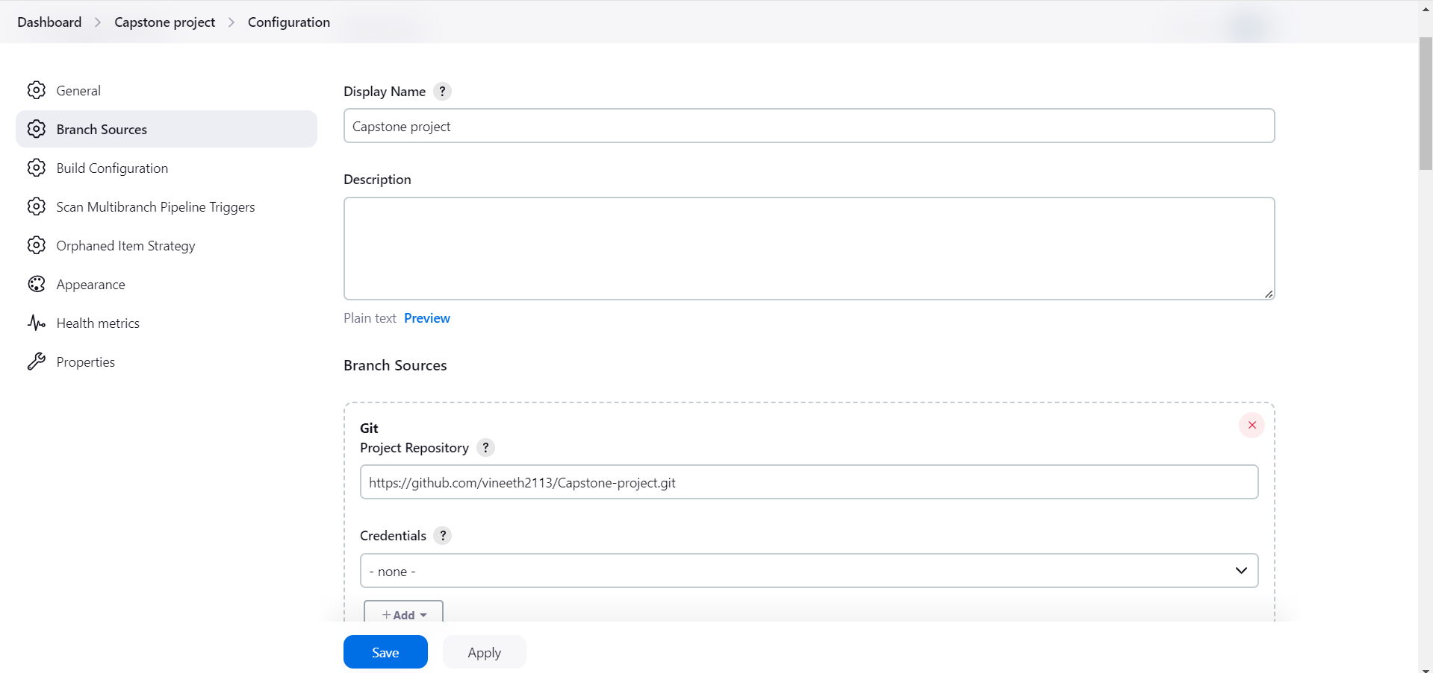

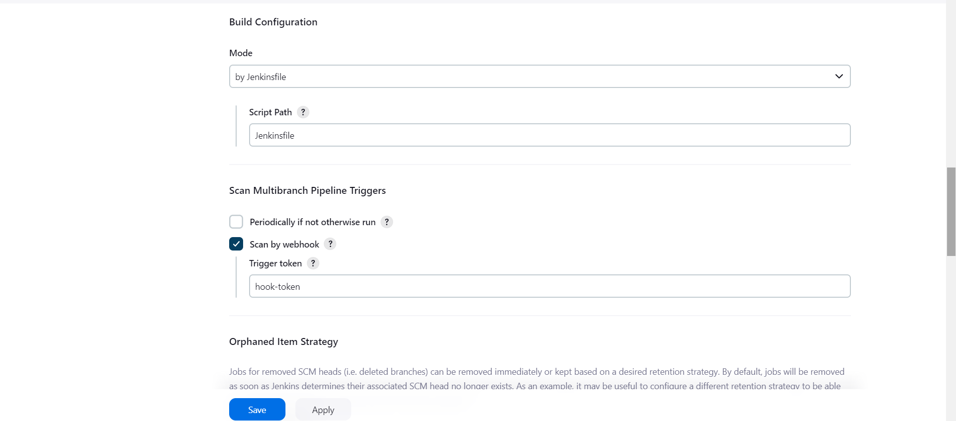

DEV Branch job:

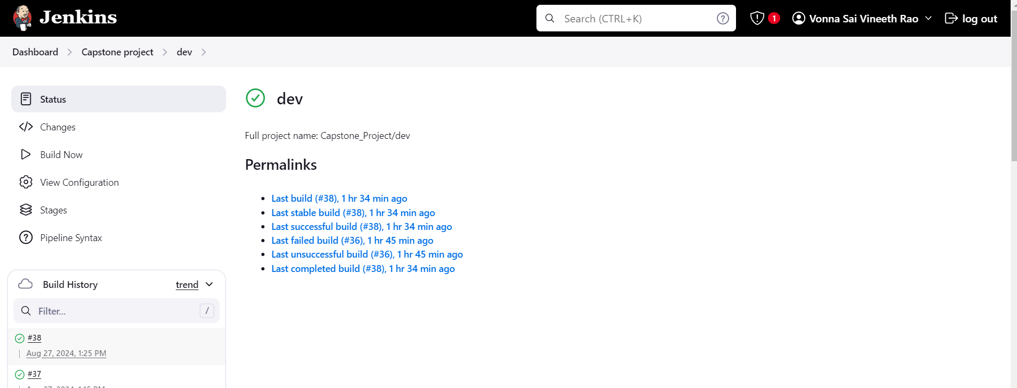

MainBRanch job:

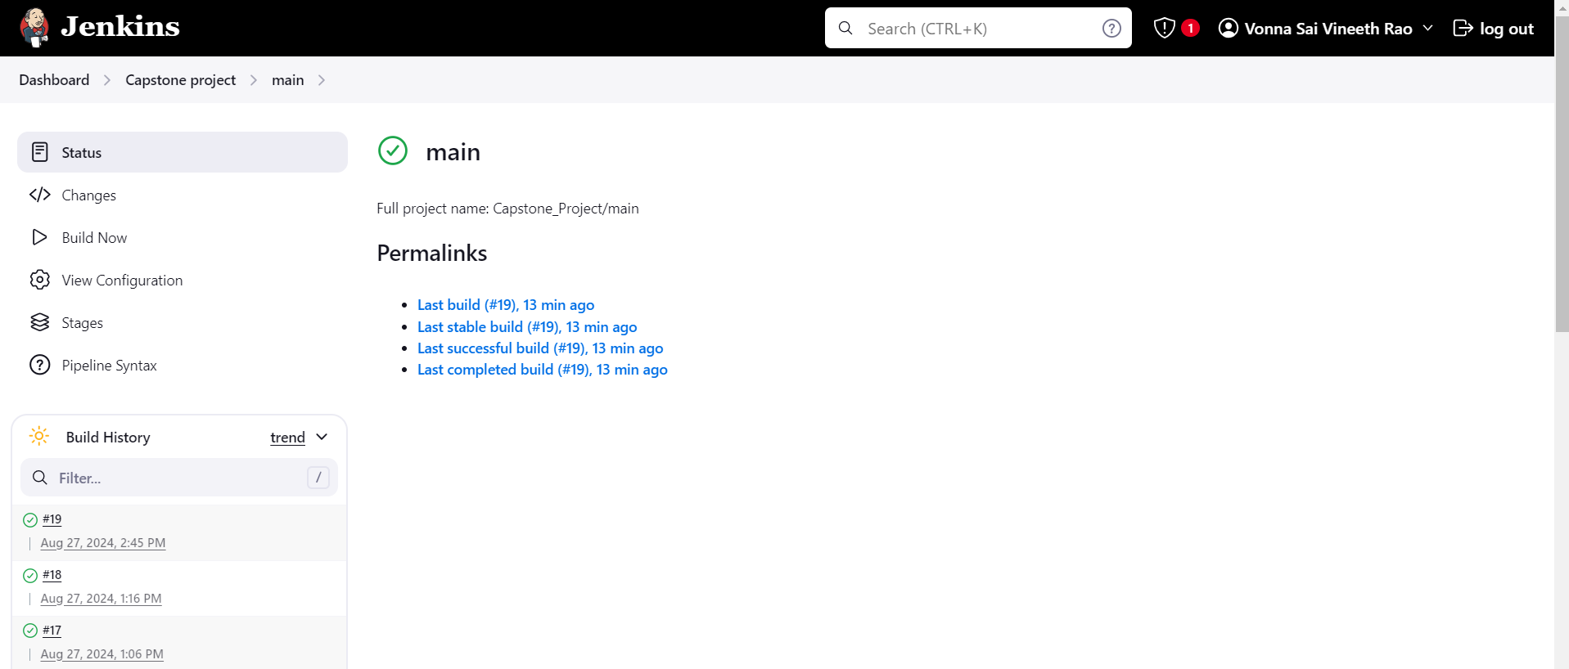

Deployment:

Deployed URL:http://54.205.238.45:80/

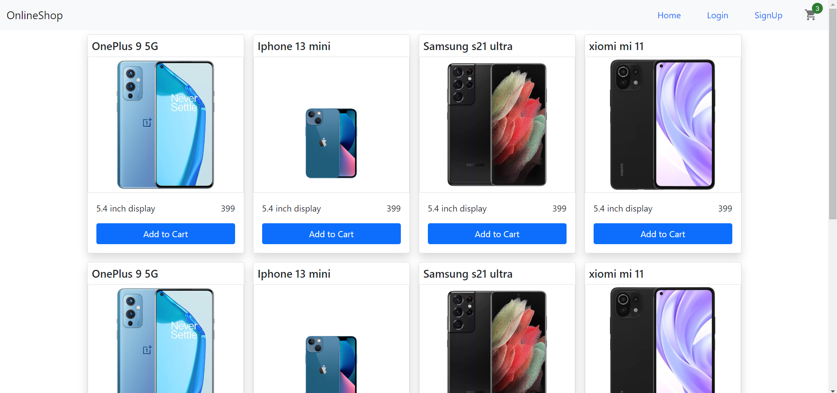

Docker Hub:

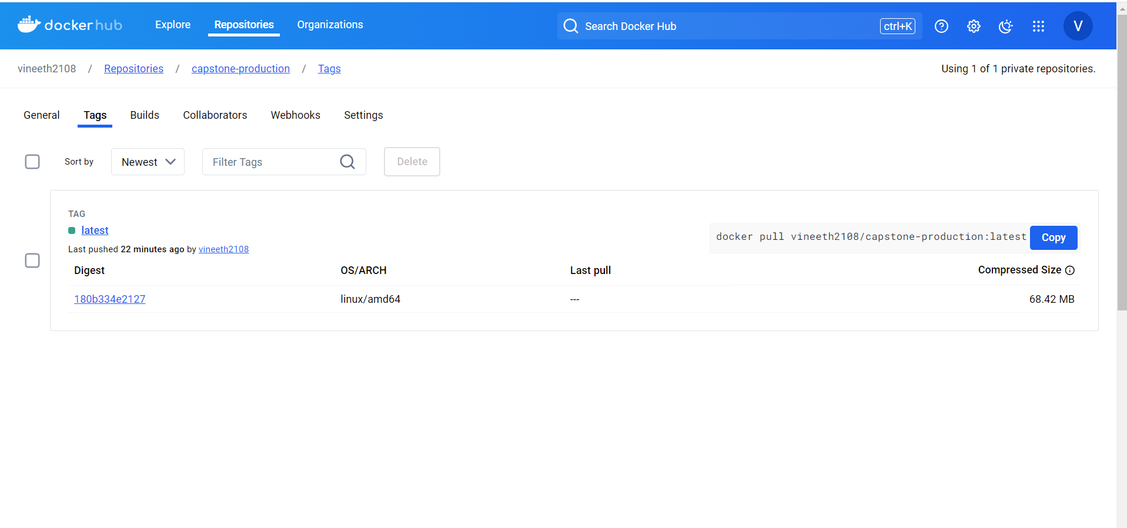

Prod image: docker pull vineeth2108/capstone-production:latest

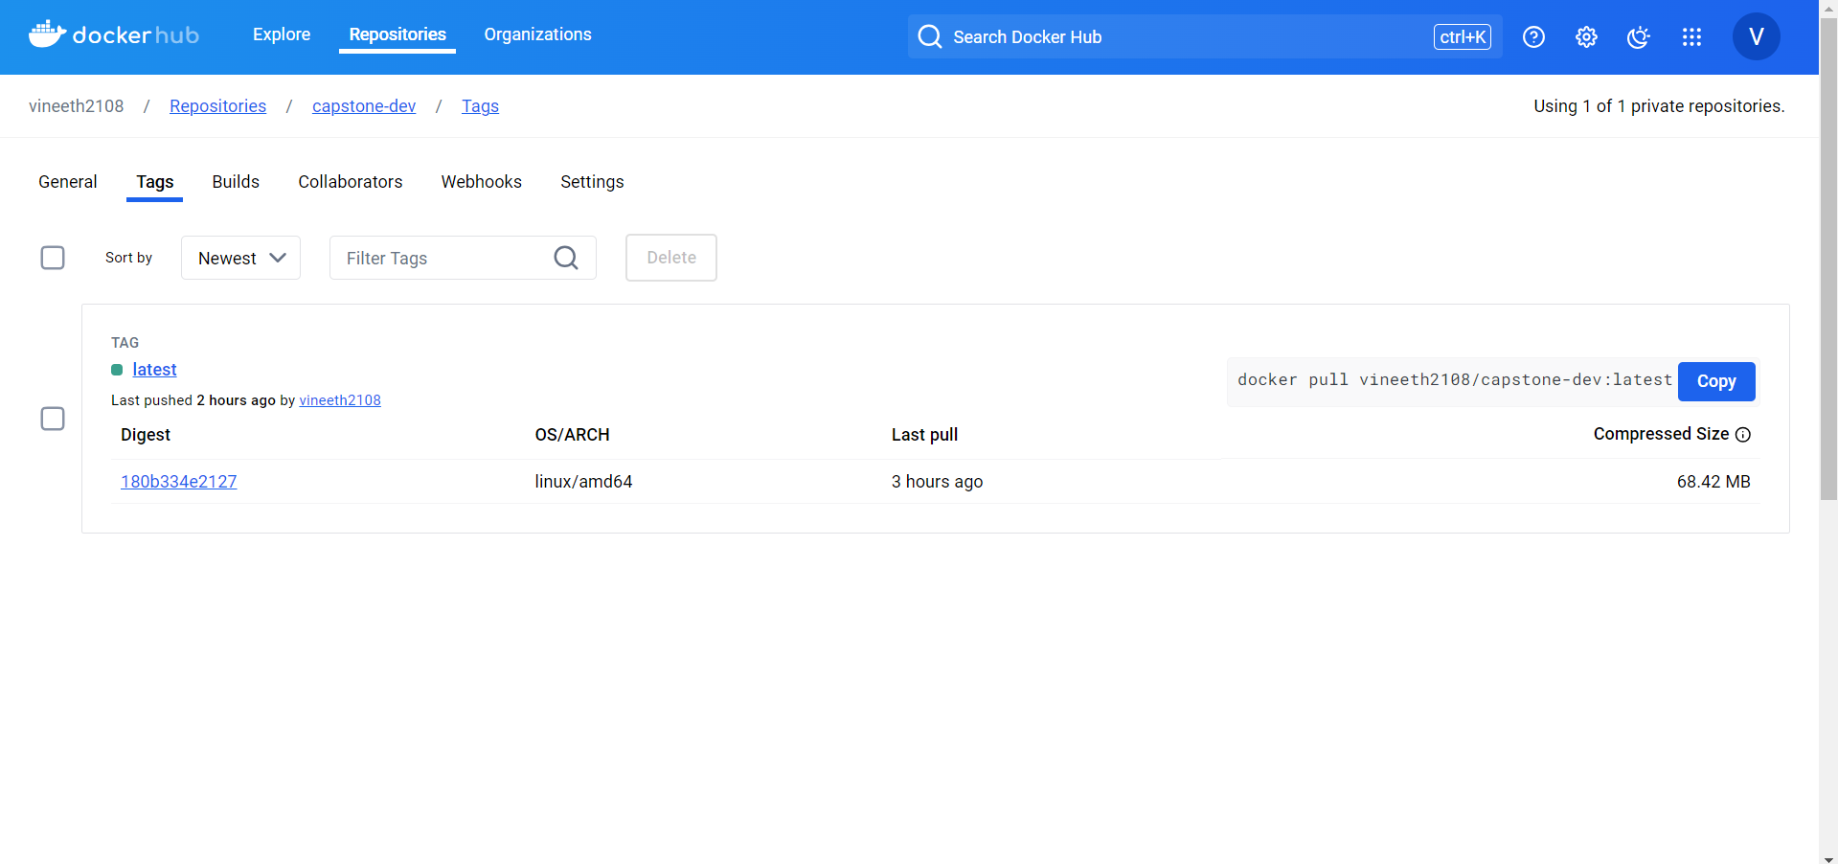

Security group:

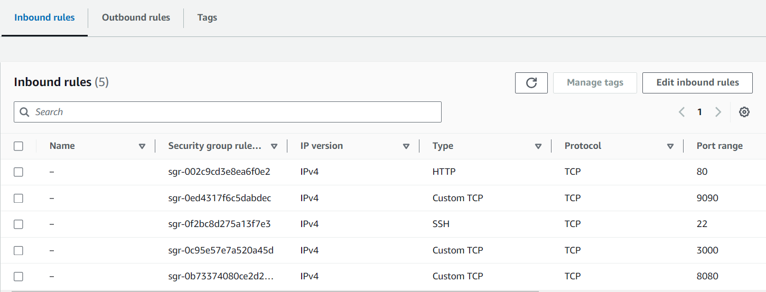

Port 80: Deployment.

Port 9090: Prometheus.

Port 3000: Grafana

Port 8080: Jenkins.

Monitoring Prometheus and Grafana

Prometheus

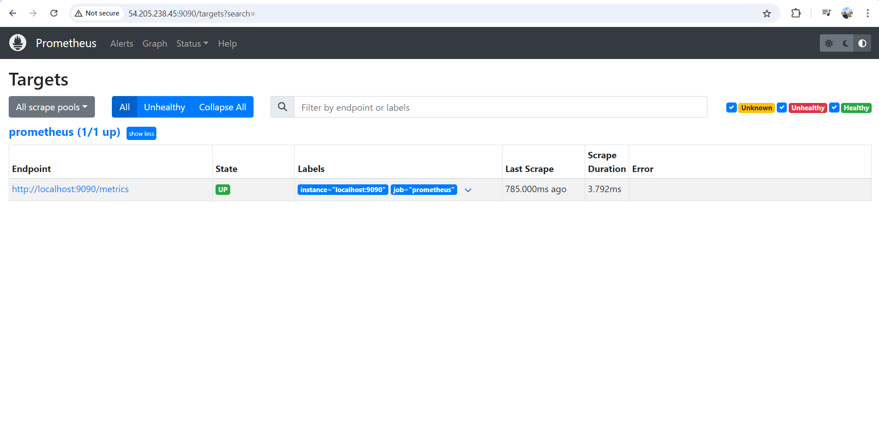

Grafana:

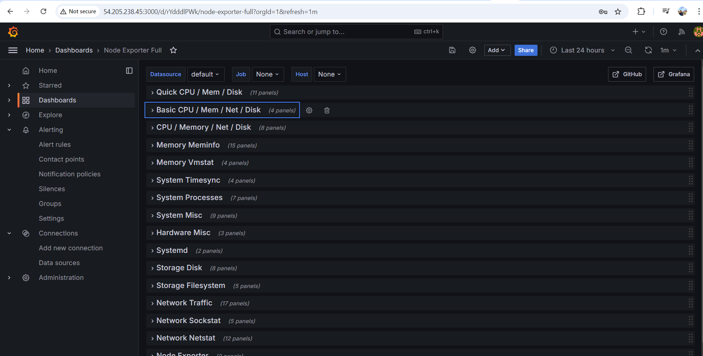

Email Notification:

